Art Questions.
Name.
Institution.
Date.

Option 1.
The Statue of Liberty.
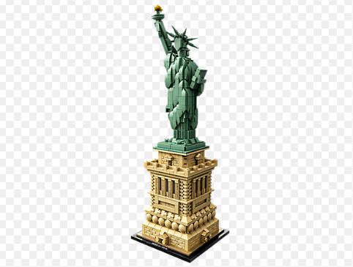
https://shop.lego.com/en-US/Statue-of-Liberty-21042
This piece of art was developed by Andy Warhol’s in 1962 and it was entitled “Statue of Liberty” (Joffe, 2015).He used silkscreen ink and spray paint on linen. The image rhymes with its name suggestion that it is a statue of liberty which is repeated in a pattern. The painting is still displayed at the Arkansas Arts Center. However, it is still owned by Andy Warhol Museum located in Pittsburgh- Pennsylvania (Joffe, 2015). The painting is approximately 80 × 61 inches. In essence, the painting is big and hence one has to look up or stands far away to view it entirely.
Observably, the image is featured with a repeated pattern in the painting that depicts the Statue of Liberty stand face on and the viewer is able to view its features from legs upwards. The torch is well seen, and we can also view the horizon background. Arguably, the “Statue of Liberty” painting is featured with a cool hue of blue, but not fixed to it. It is also observable that the image is not fixed on the linen, however, it is slightly aligned to the right quarter of the entire painting, thus, and much of the space is left unpainted (Joffe, 2015). Analytically, the element of repetition in the painting gives the piece a sense of unity. The element of variety is well represented by the difference in the many patterns in the painting. In its normal setting, the painting uses sky as its background in the color of linen. The grid is featured with six implied lines which are created by repetition of the image.
From another point of view, the painting has left some areas of unpainted linen along the top row. The painting has a light in each of its rectangles illuminating the statue and modeling it in three dimensions. More on this, the face of the painting changes from clearly visible to somehow visible and it entirely covered across each of the rectangles. Also, the statue is fixed, giving an implication of unity. Different patterns and layers captured in the painting depict the aspect of painting along the statue. The element of symmetry is not well depicted and hence the work is slightly unbalanced. More importantly, the “Statue of Liberty” is large; however, its picture is represented in a shrunken size as well as size and then multiplies into many pieces with different patterns.
From my point of understanding, the Statue of Liberty serves as universal indicator of freedom. It also acts as symbol of the friendship and connectedness amid people of different ethnicity in the context of the United States. It is an indicator of mutual desire for liberty amid diverse populations. The Statue of Liberty is mother of all exiles. As such, it creates a welcoming environment where every human will tend to feel an American with the due freedom. It represents the entire United States.
There are greater connections amid this painting and the literacy from other pieces. It effectively applies the principles and elements of art. It meets all the rhetorical appeals to attract the audience. It is quite educative and it depicts the social needs of our wider society (Moreno, 2017). The ideal connection with this image to the ideal world is that everyone is in need of freedom and autonomy. The painting is widely useful in sensitizing the public in the need to maintaining freedom and dignity for each of the humans.
Option 6.
Album Art Online.
Album art, also known as the cover art, is a type of artwork that represents photographs or published products such as CDs, video games, comic books, books, newspapers, music albums and videotape among others (James, 2014). Primarily, the album art has a commercial function in that it is increasingly used for the purpose of promoting the products displayed on. More on this, cover art is well used for appealing purposes and it can be used artistically with a connection to the product being promoted. Arguably, the album art is used for marketing purposes.
The album art online traces its origin back in 1938. It was first developed by Alex Steinwess, a graphic designer and art designer who lived up to the age of 94. Steinwess pioneered the idea of custom artwork to record album covers. With this idea, he designed and used the first covers which were comprised of his original design (James, 2014). As evident, this technology replaced the existing non branded 78 rpm record contained inside the protective pasteboard covers .The covers entailed lesser features which contained only the title of the album, and then the artist applied a stamp on the cover and spine. The first album art was quite aesthetic and the technology was swiftly accepted in the artistic world and hence overhauling the ordinary practices. Since inception of the cover art, the knowledge has gone through significant transitions. Nowadays, the cover art has advanced with appealing decorations and showing its title and the name of the artist in a more comprehensive manner.
My selected album cover is that Elvis Presley (1956) which is presented below.
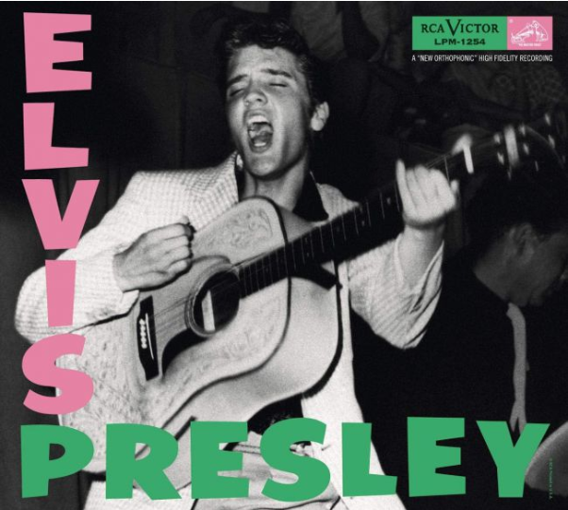
https://www.creativebloq.com/features/the-20-best-album-covers-of-all-time

This is one of the most iconic album art in the rock history dating back 1956. The artist (Presley) designed this album cover for commercial purposes. He intended to publicize his music in a more appealing and entertaining manner. The musician also used this album to depict that his music was worth to be accepted in the wider population (James, 2014). As a result, the artist became more famous and recognized than what the music symbolized. With this publicity, Presley was later rebranded “The King”. This iconic cover went viral and it was later copied by other artists to publicize their products and appeal to the public.
Artistry is a record label used as a mark of identity for an artistry product. Artistry plays a core role in the context of recording. First, it is used for differentiation purposes. Each record label is found to be unique in a way that potential customers can effectively distinguish it from other related products. Artistry is also used for aesthetic purpose (Word Press, 2011). As such, it is used as a platform for attending to audience’s rhetorical appeals and these include; the ethos, pathos and logos. Artistry is used for advertising. This is by passing essential information about what is contained in the record.
In reflection to the selected album cover, it is interesting that the designer adhered to the rhetorical appeals effectively. From the observation, the album cover is quite entertaining and the viewer is able to conclude what message it tries to put across (Word Press, 2011). More on this, the album cover is commercial oriented; it can easily entice customers to buy the product being presented. It also creates awareness about the artist.

References.
James, S. (2014). The Evolution of Album Art Through Decades of Music (Doctoral dissertation, Radford University).
Joffe, J. (2015). 130 Years Ago, France Gave Us The Statue of Liberty. The Observer.
Moreno, B. (2017). The Statue of Liberty. Arcadia Publishing.
WordPress (2011). The first ever designed album cover. https://itsasmallweb.wordpress.com/2011/07/20/the-first-ever-designed-album-cover/

